中国财政科学研究院
2019年招收攻读博士学位研究生入学综合考核
英语笔试题

Please pick either of the following two questions and write a composition. Your writing will be about 300 words.
Question 1
Globalization has pros and cons. Some people do believe it is a good thing but others do not. Read the report “THE PUBLIC HAS MIXED VIEWS ON GLOBALIZATION” below and give yours opinion. Present arguments to support your view.

THE PUBLIC HAS MIXED VIEWS ON GLOBALIZATION
How do Americans feel about globalization? Listening to the debates can be confusing. Not surprisingly, polls vary widely depending on how and when the question is posed.

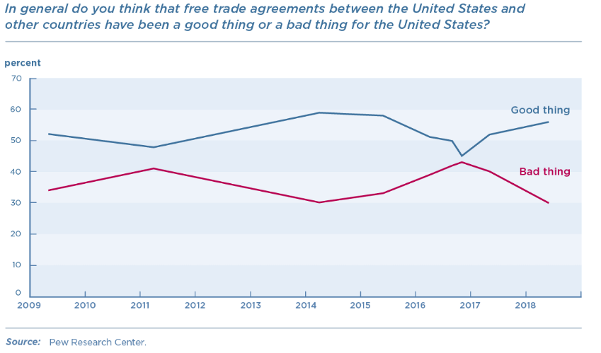
This Pew Research poll finds more support than not for free trade agreements. But a 2016 Bloomberg poll asked, “Do you think US trade policy should have more restrictions on imported foreign goods to protect American jobs, or have fewer restrictions to enable American consumers to have the most choices and the lowest prices?" This resulted in 65 percent of respondents wanting more restrictions, the opposite of the sentiment expressed in the Pew poll.
Globalization can be a hard sell to the public because the benefits are widely distributed and not as easily understood, compared with the personal costs to very specific companies or workers.
The problem is compounded because policymakers have done little to help workers and communities adjust at a time when the wealthiest Americans have gained the most in recent years. In general, younger people are more supportive of free trade, as most have never known a world without the current system.
Before 2016, Republicans generally favored US trade deals and Democrats generally voted against them. President Trump canceled TPP and has threatened withdrawing from NAFTA, the Korea-US Free Trade Agreement (KORUS) (later revised and signed), and the WTO. His administration has negotiated the US-Mexico-Canada Agreement (USMCA) to replace NAFTA; the agreement now faces ratification in each country. Some GOP congressional members have spoken out against Trump on certain trade issues or have drafted bills to limit his authority on tariffs. The White House is pushing for more power to impose tariffs.

Question 2
As stated in the report “TAX CUTS: BENEFITS AND PROBLEMS”, tax cuts may stimulate consumption, encourage investment, boost economic growth, and the other side may be the problems such as inequality, budget imbalance, public borrowing and so on. Focus on ONE perspective to make your discussion.
TAX CUTS: BENEFITS AND PROBLEMS
For years, U.S. firms have shouldered one of the highest corporate income tax rates in the world, at just under 39 percent (state and federal combined). In 2017 that was the third-highest rate among the world’s 173 nations. High corporate taxes affect business decisions in socially harmful ways. Taxes discourage deals that would have produced more goods for consumers, more employment, better wages, and better payouts to shareholders. These missed opportunities are known as “deadweight losses.” By cutting the corporate rate to 21 percent, Congress has reduced those losses, which may be why several firms have announced wage increases, employee bonuses, and business expansions following the passage of the new tax law.
But even with this economic boost, the tax cut is expected to result in less government revenue. How to make up for that lost money? One way would be to raise taxes on rich individuals, which shouldn’t produce as many deadweight losses. The new tax law does this to some extent by limiting tax breaks used by the rich. Lawmakers plan to make up for that lost money by increasing government borrowing. There’s nothing necessarily wrong with borrowing; it is an appropriate way to finance long-lived goods like roads and military hardware. But this new borrowing would go mainly to covering government operating expenses. That means the new tax law isn’t really a tax cut at all, but simply a delayed payment.
But it’s easy for government to continue on borrowing instead of making serious spending cuts. Indeed, the President has promised to maintain or expand spending on Social Security, Medicare and Medicaid, national defense, and homeland security, which together constitute 70 percent of all federal spending. If anything, we should worry that government spending will increase following the tax cuts. Most people know the Law of Demand: the idea that if the price of some good decreases, people will want more of it. The tax cuts, in essence, reduce the price of government, which could lead to demand for more, bigger government — perhaps in the form of a new infrastructure bill and the return of congressional earmarks.

